CS 590 Introduction to Blockchain

Smart Contract with Truffle - Pragna Mallikarjuna Swamy

**Video 1: Installation, Contract Creation**

1. Installing Truffle - npm install truffle

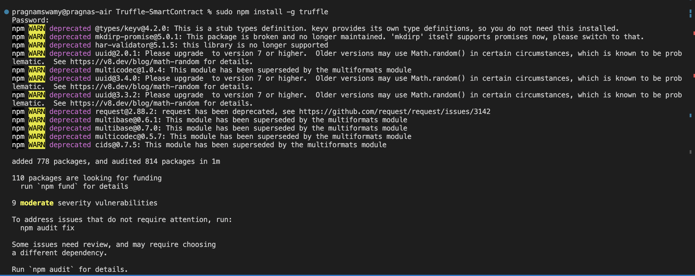

1. Unbox- npx truffle unbox

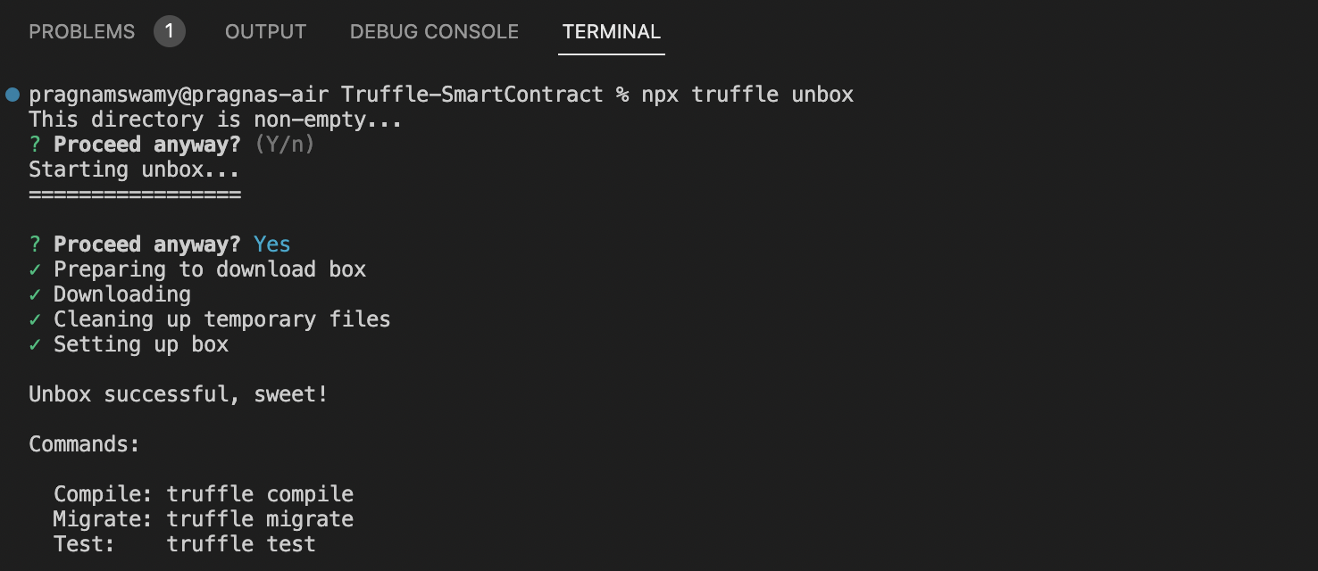

1. Create HelloWorld contract and 3_helloworld_migration.sol files

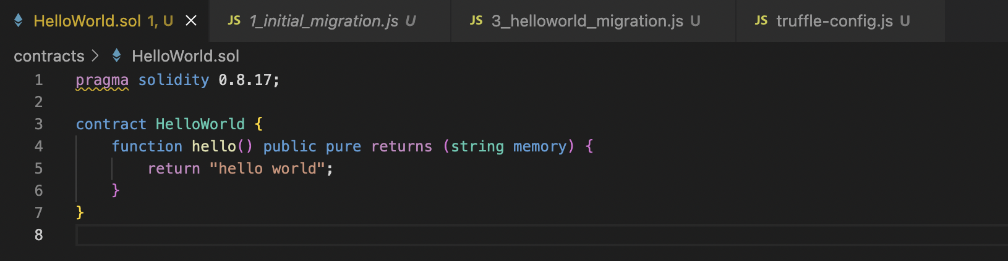

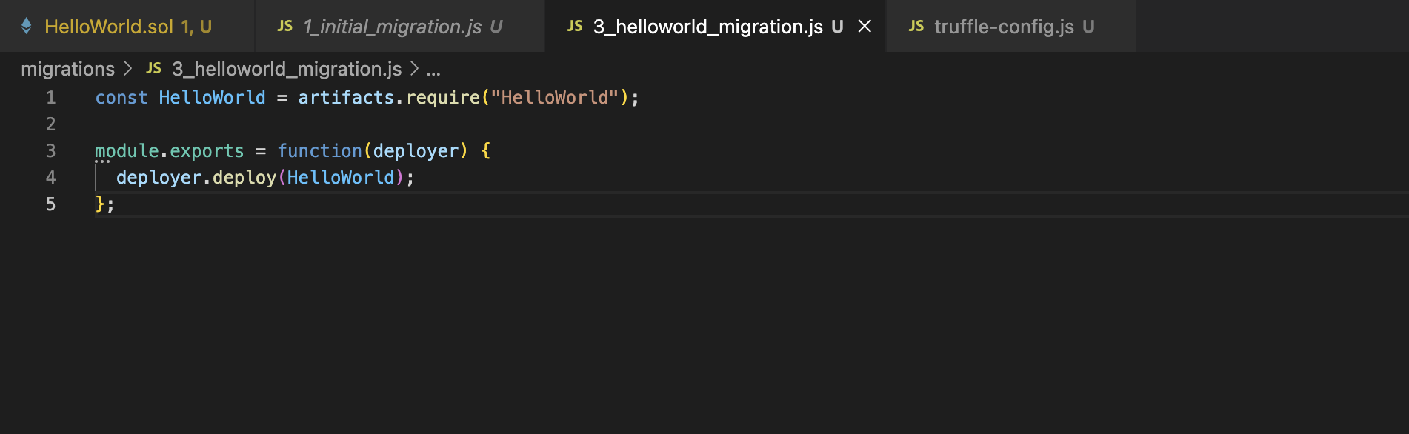

1. Compilation - npx truffle compile

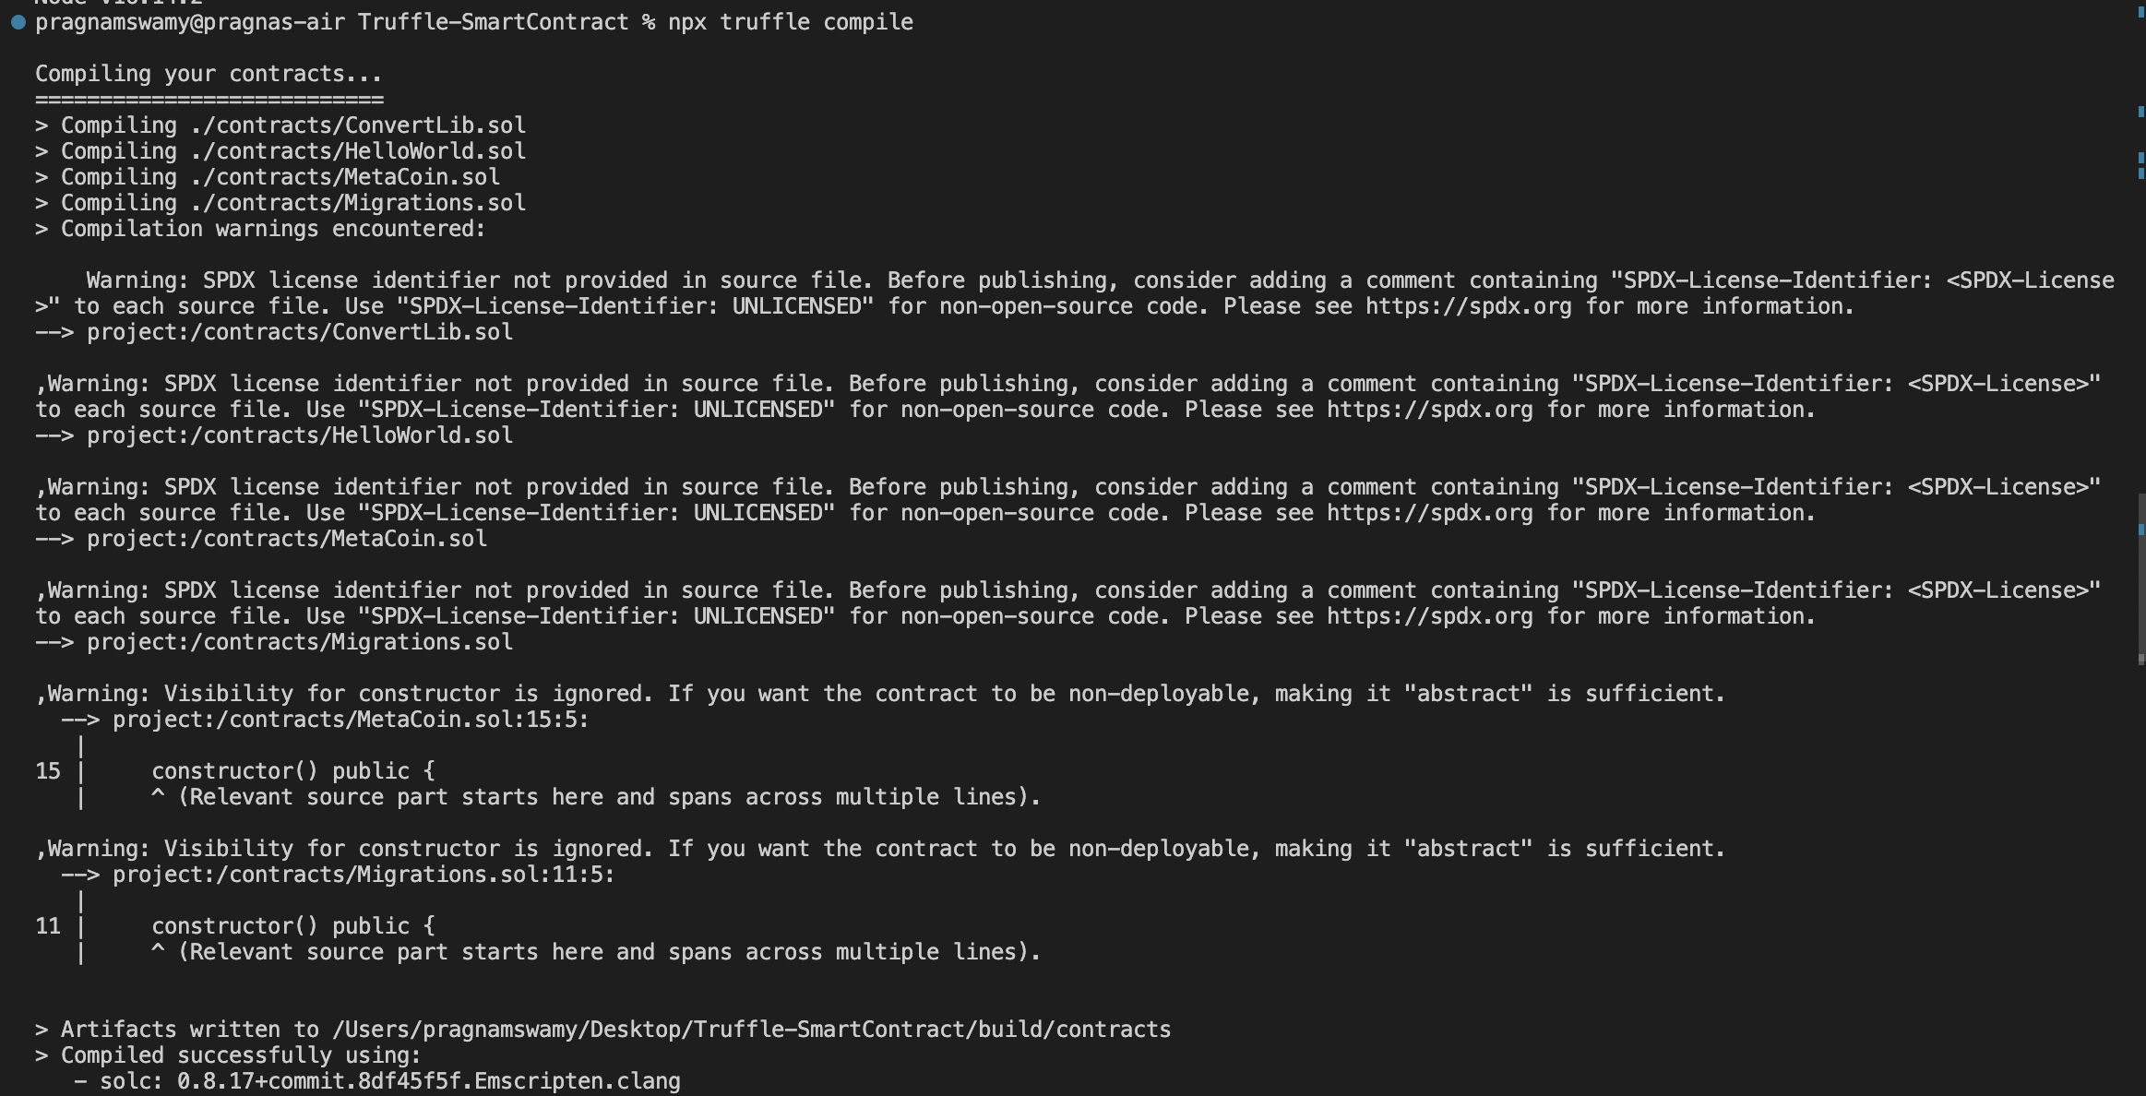

1. npx truffle develop, and truffle migrate

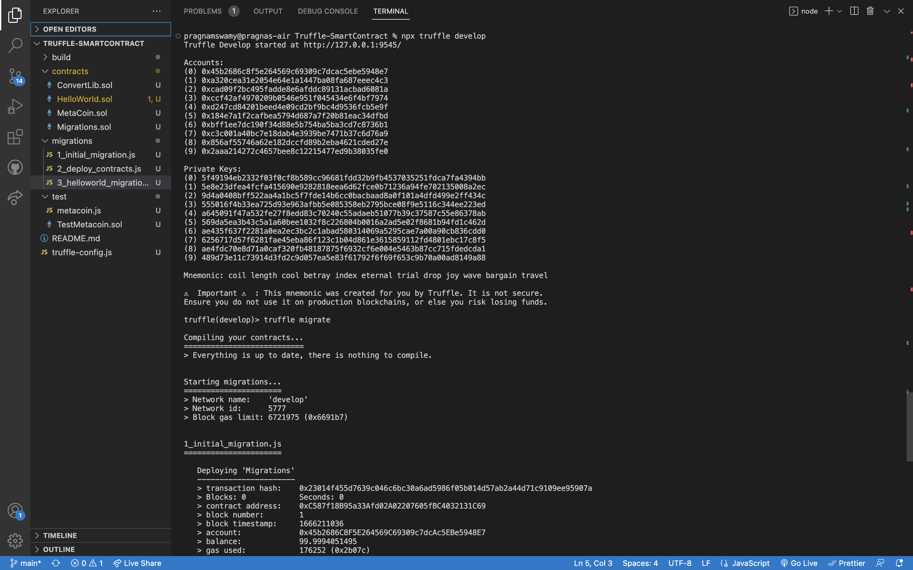

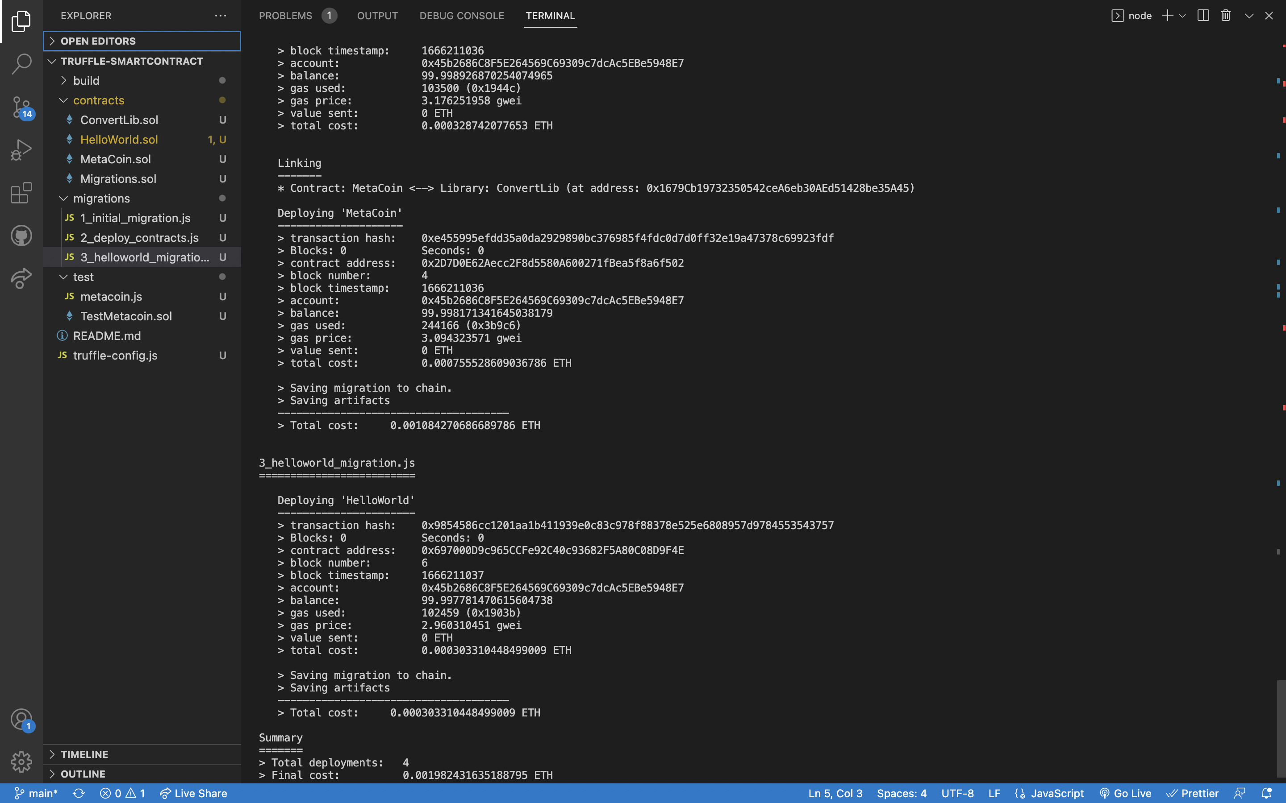

1. Interacting with the Contract using console

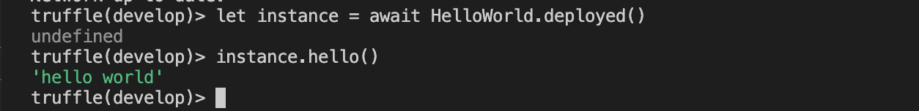

**Video 2: Migrations, Deployment**

1. Changes to helloworld.sol, 3_helloworld_migration.js and compilation

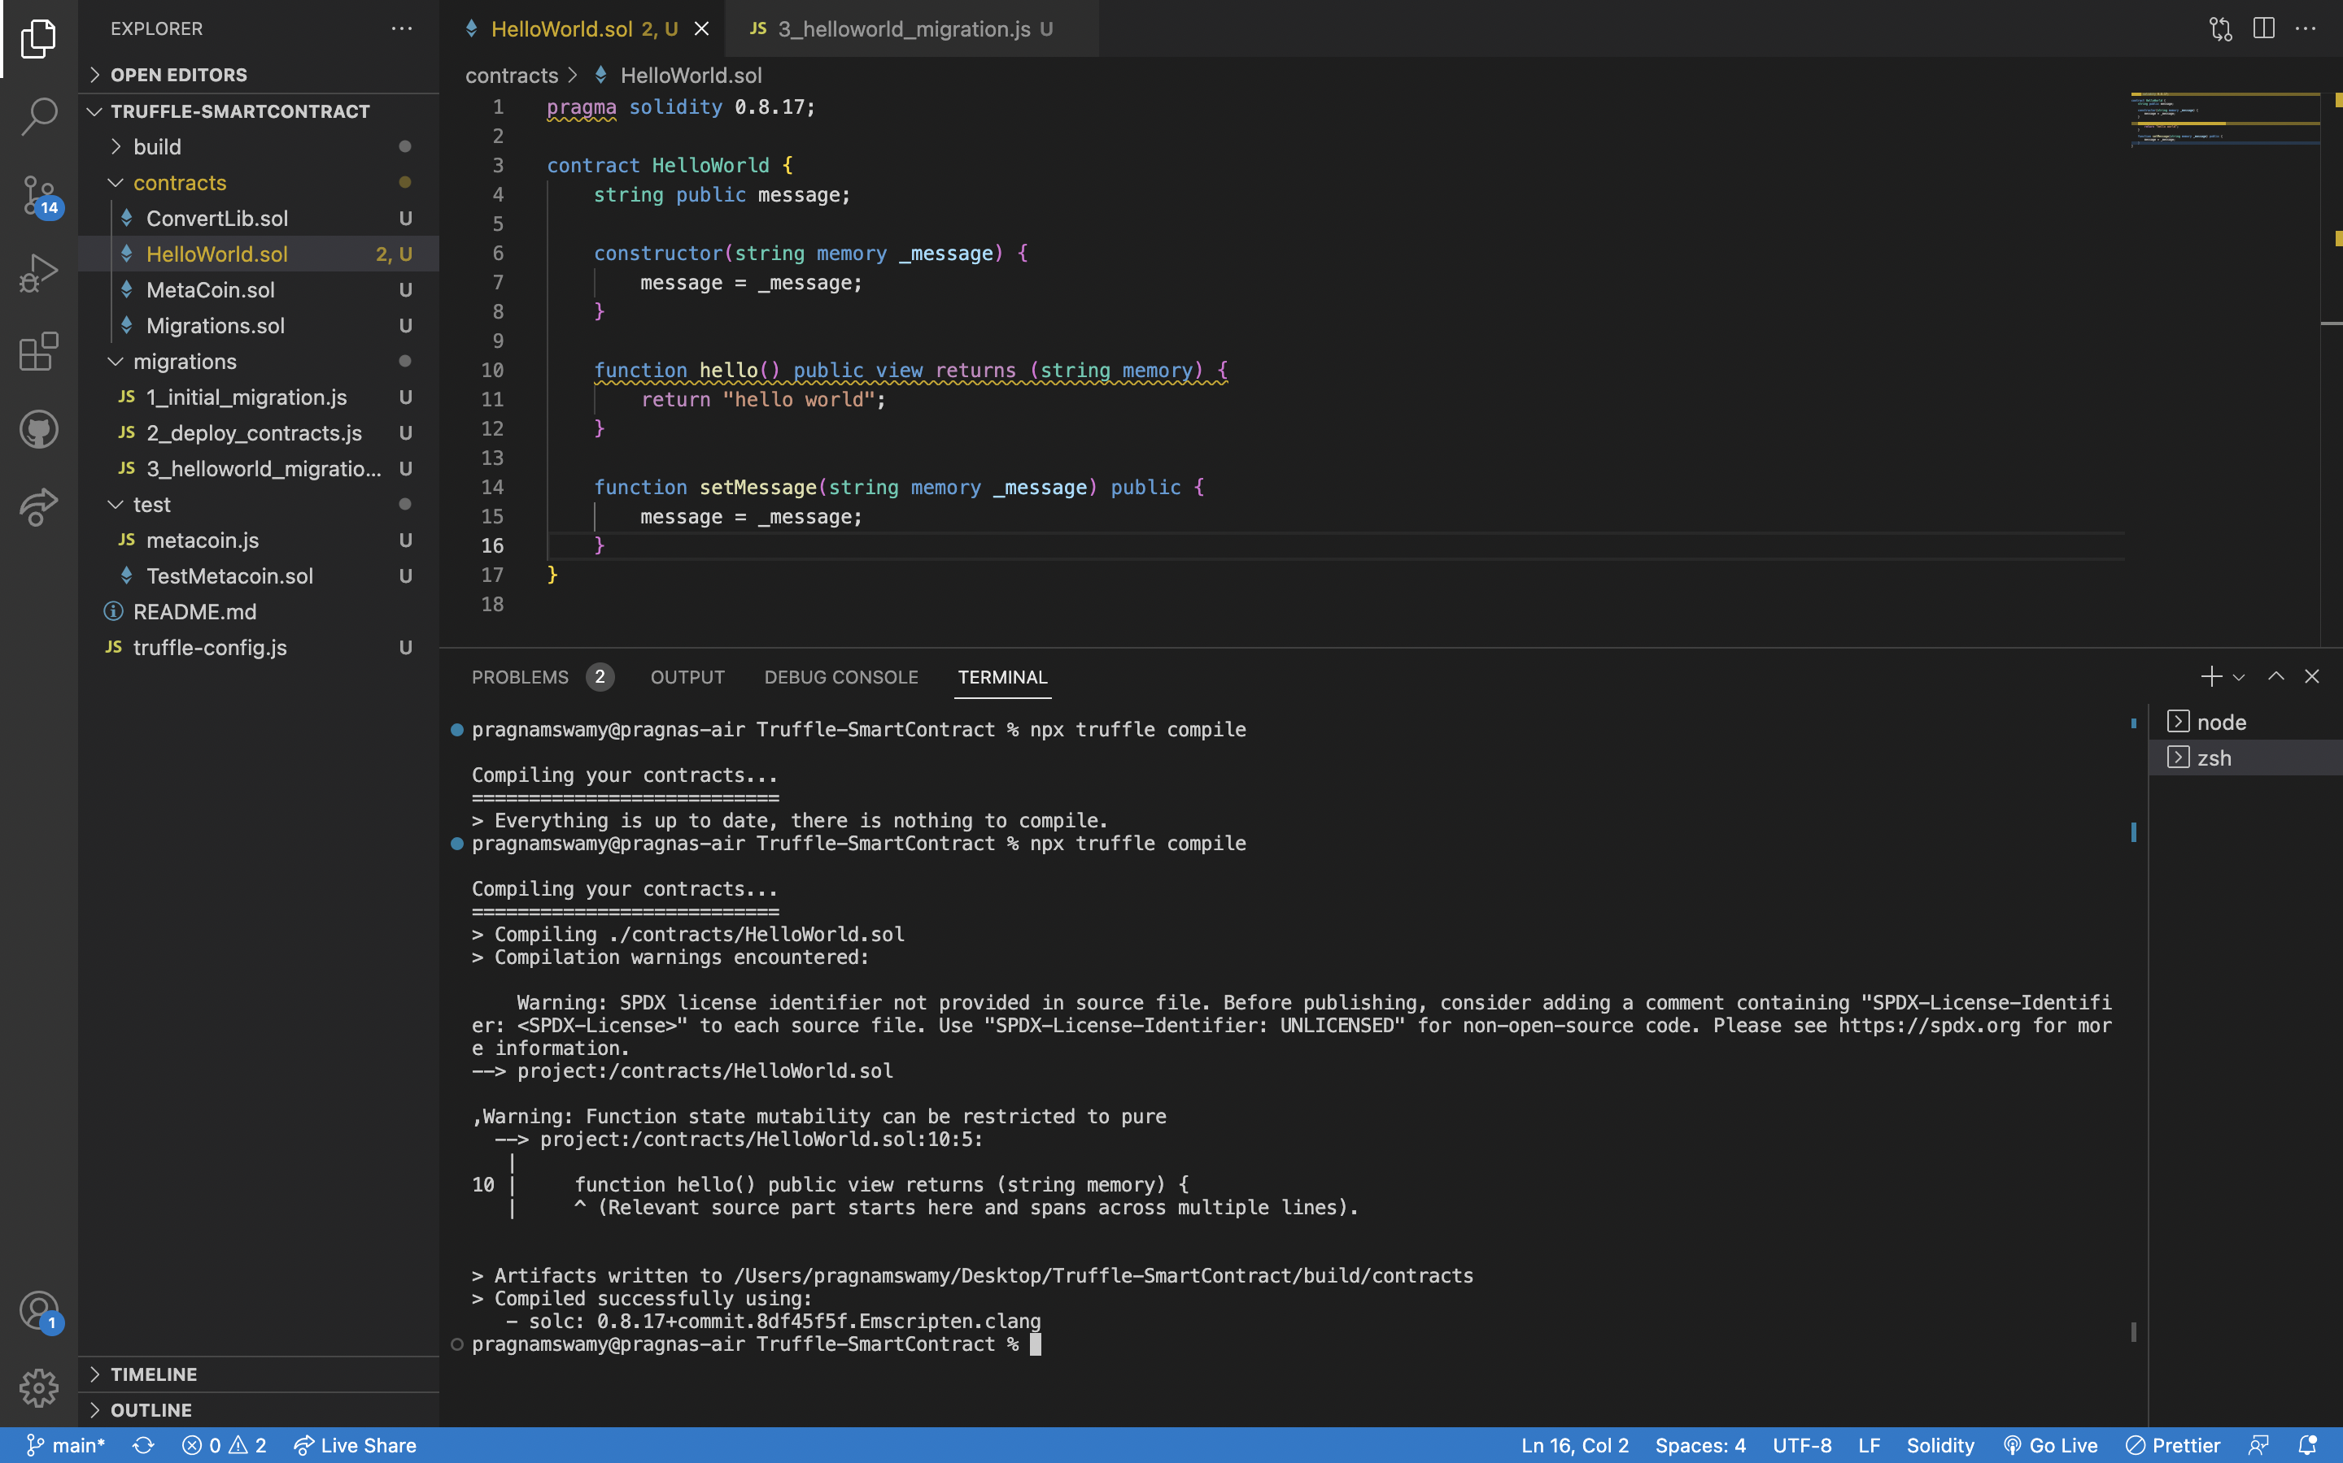

1. Develop and migrate, interacting with console

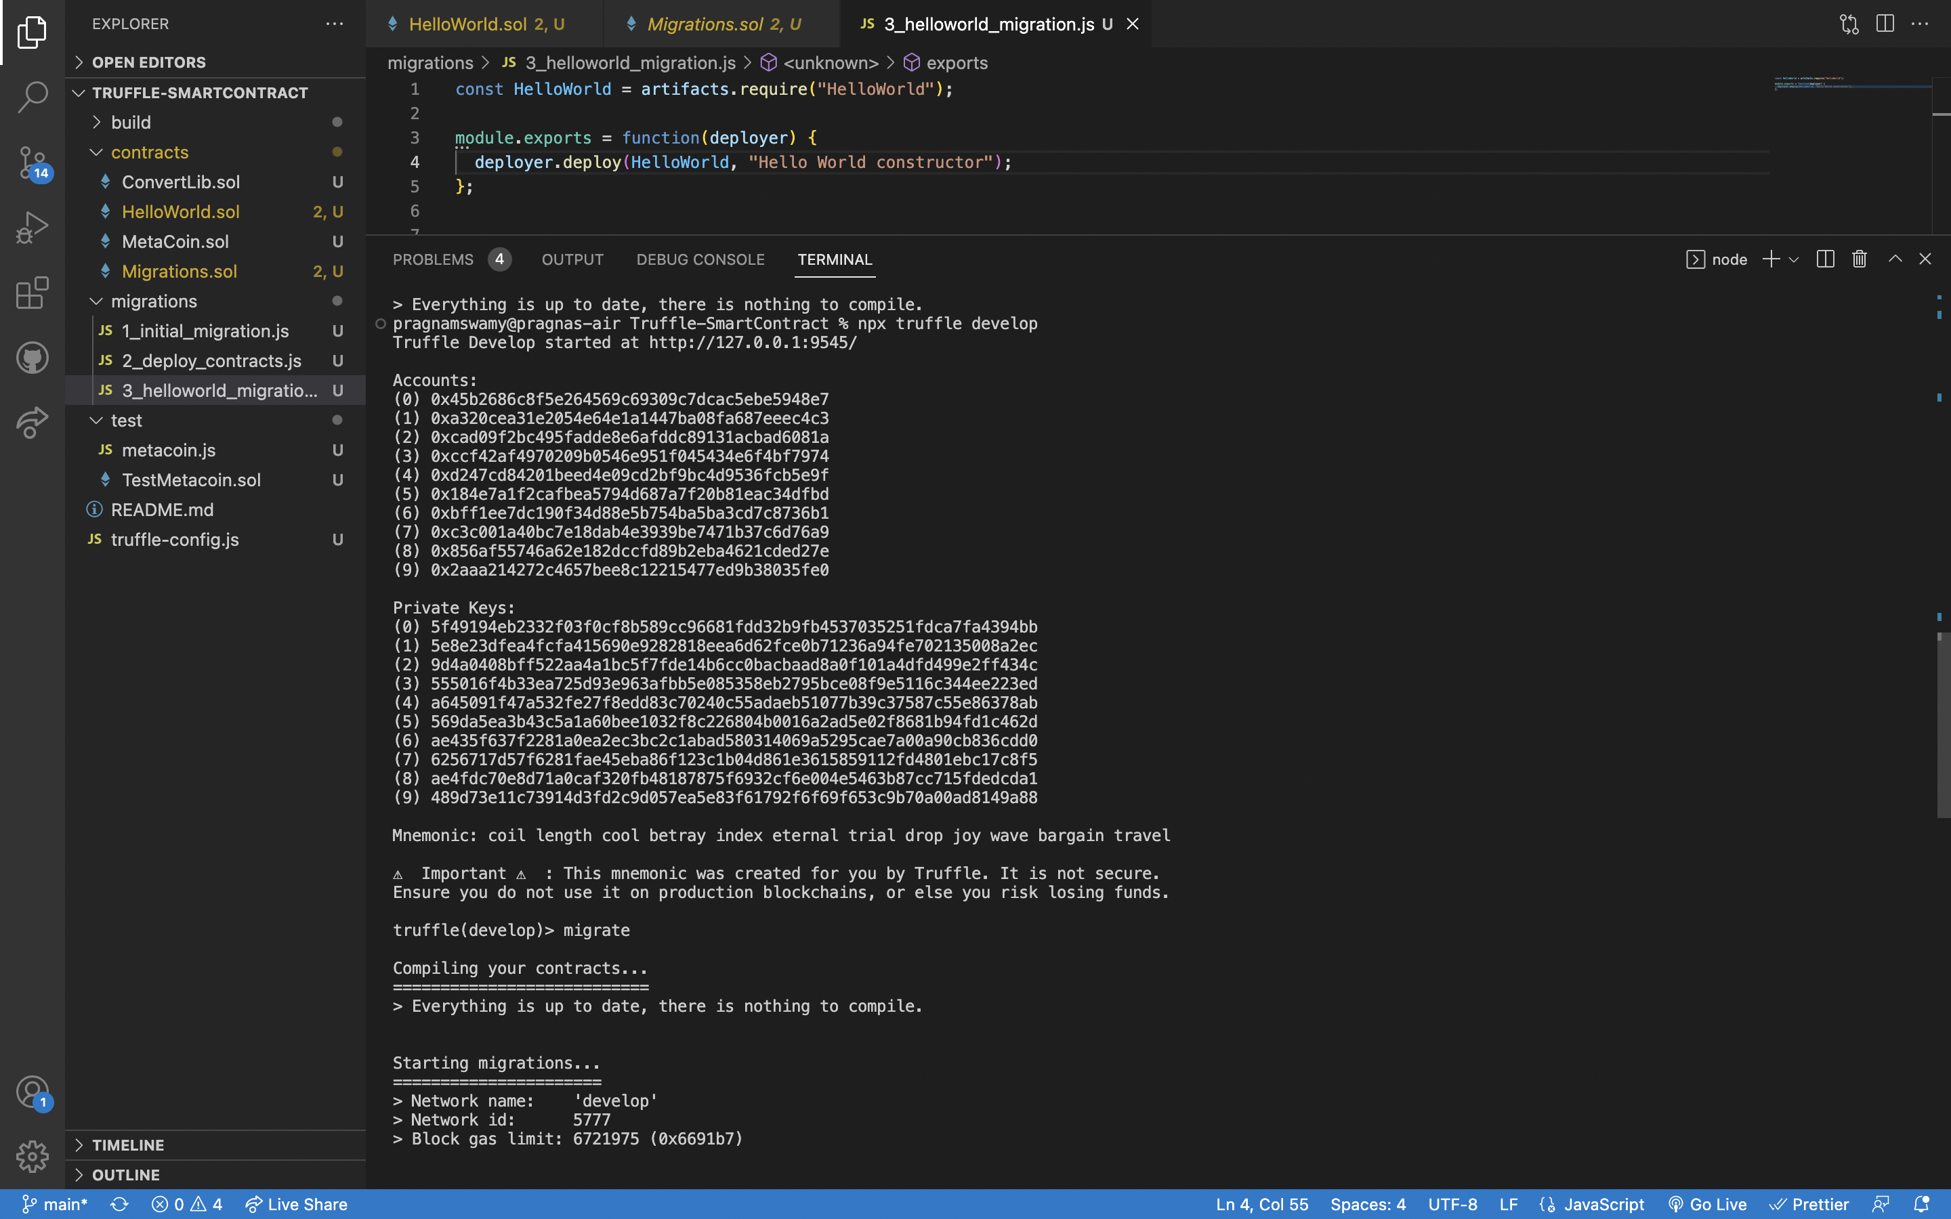

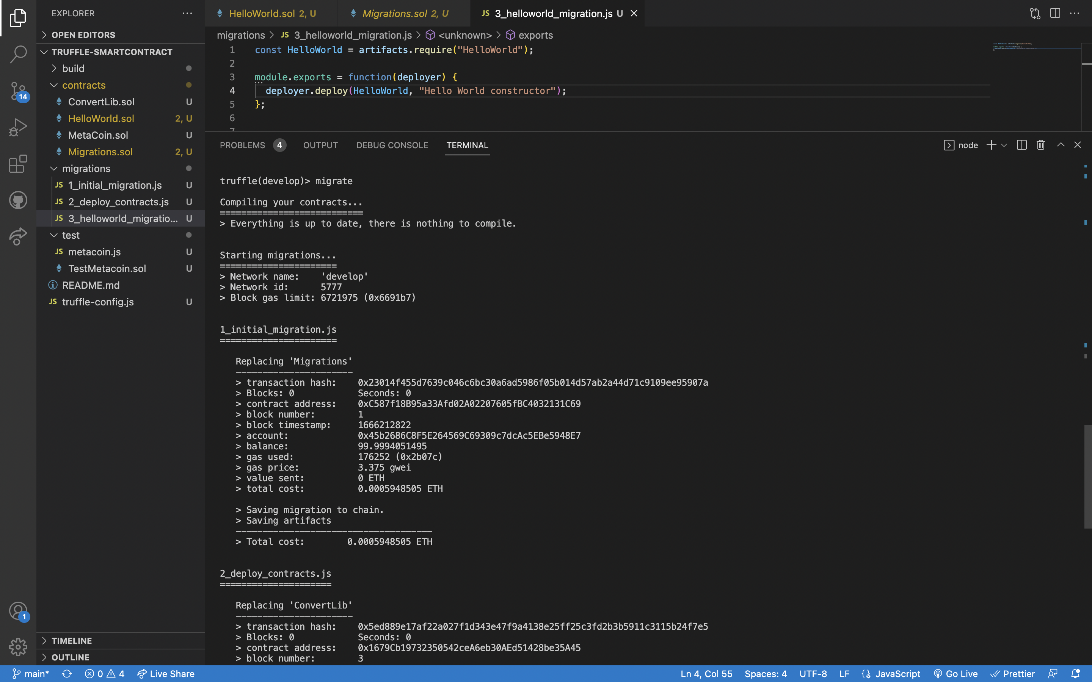

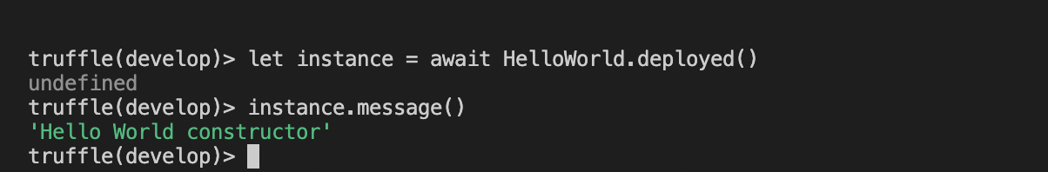

1. Adding a new message

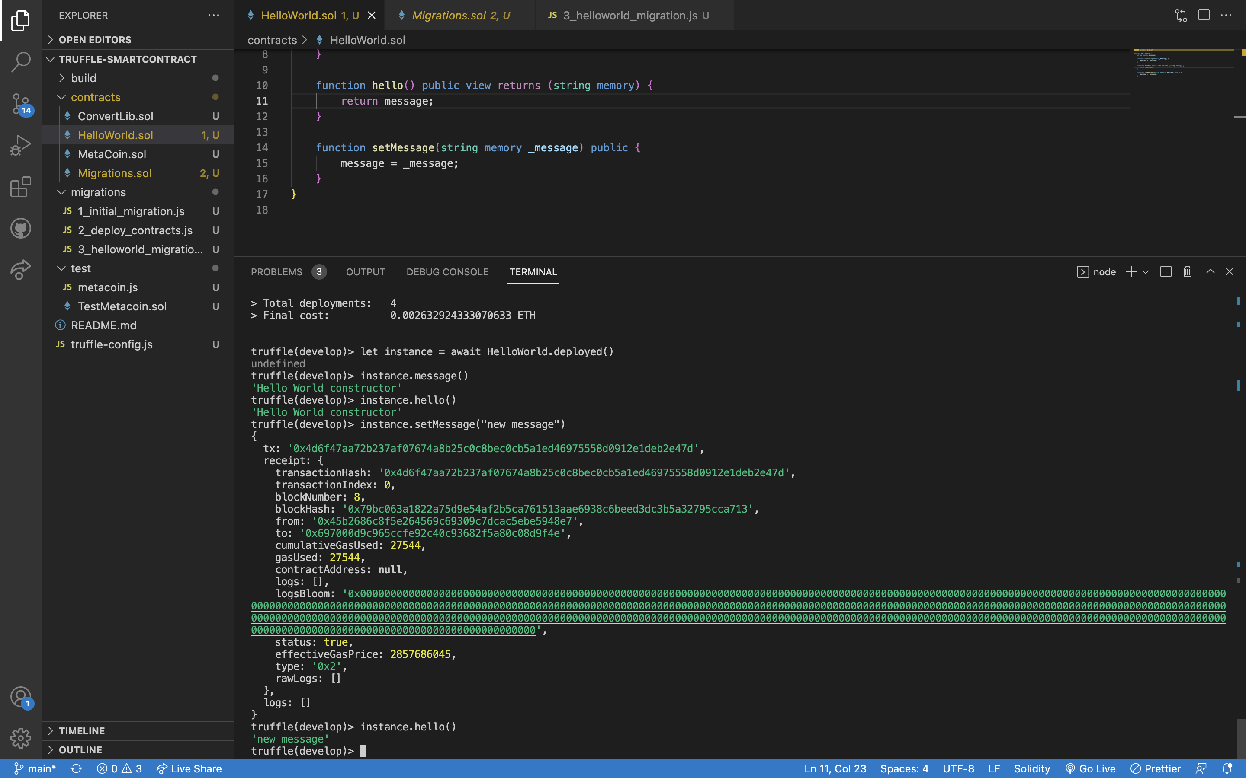

Setting a value of 1 Ether: migrate - -reset , setMessage with a value

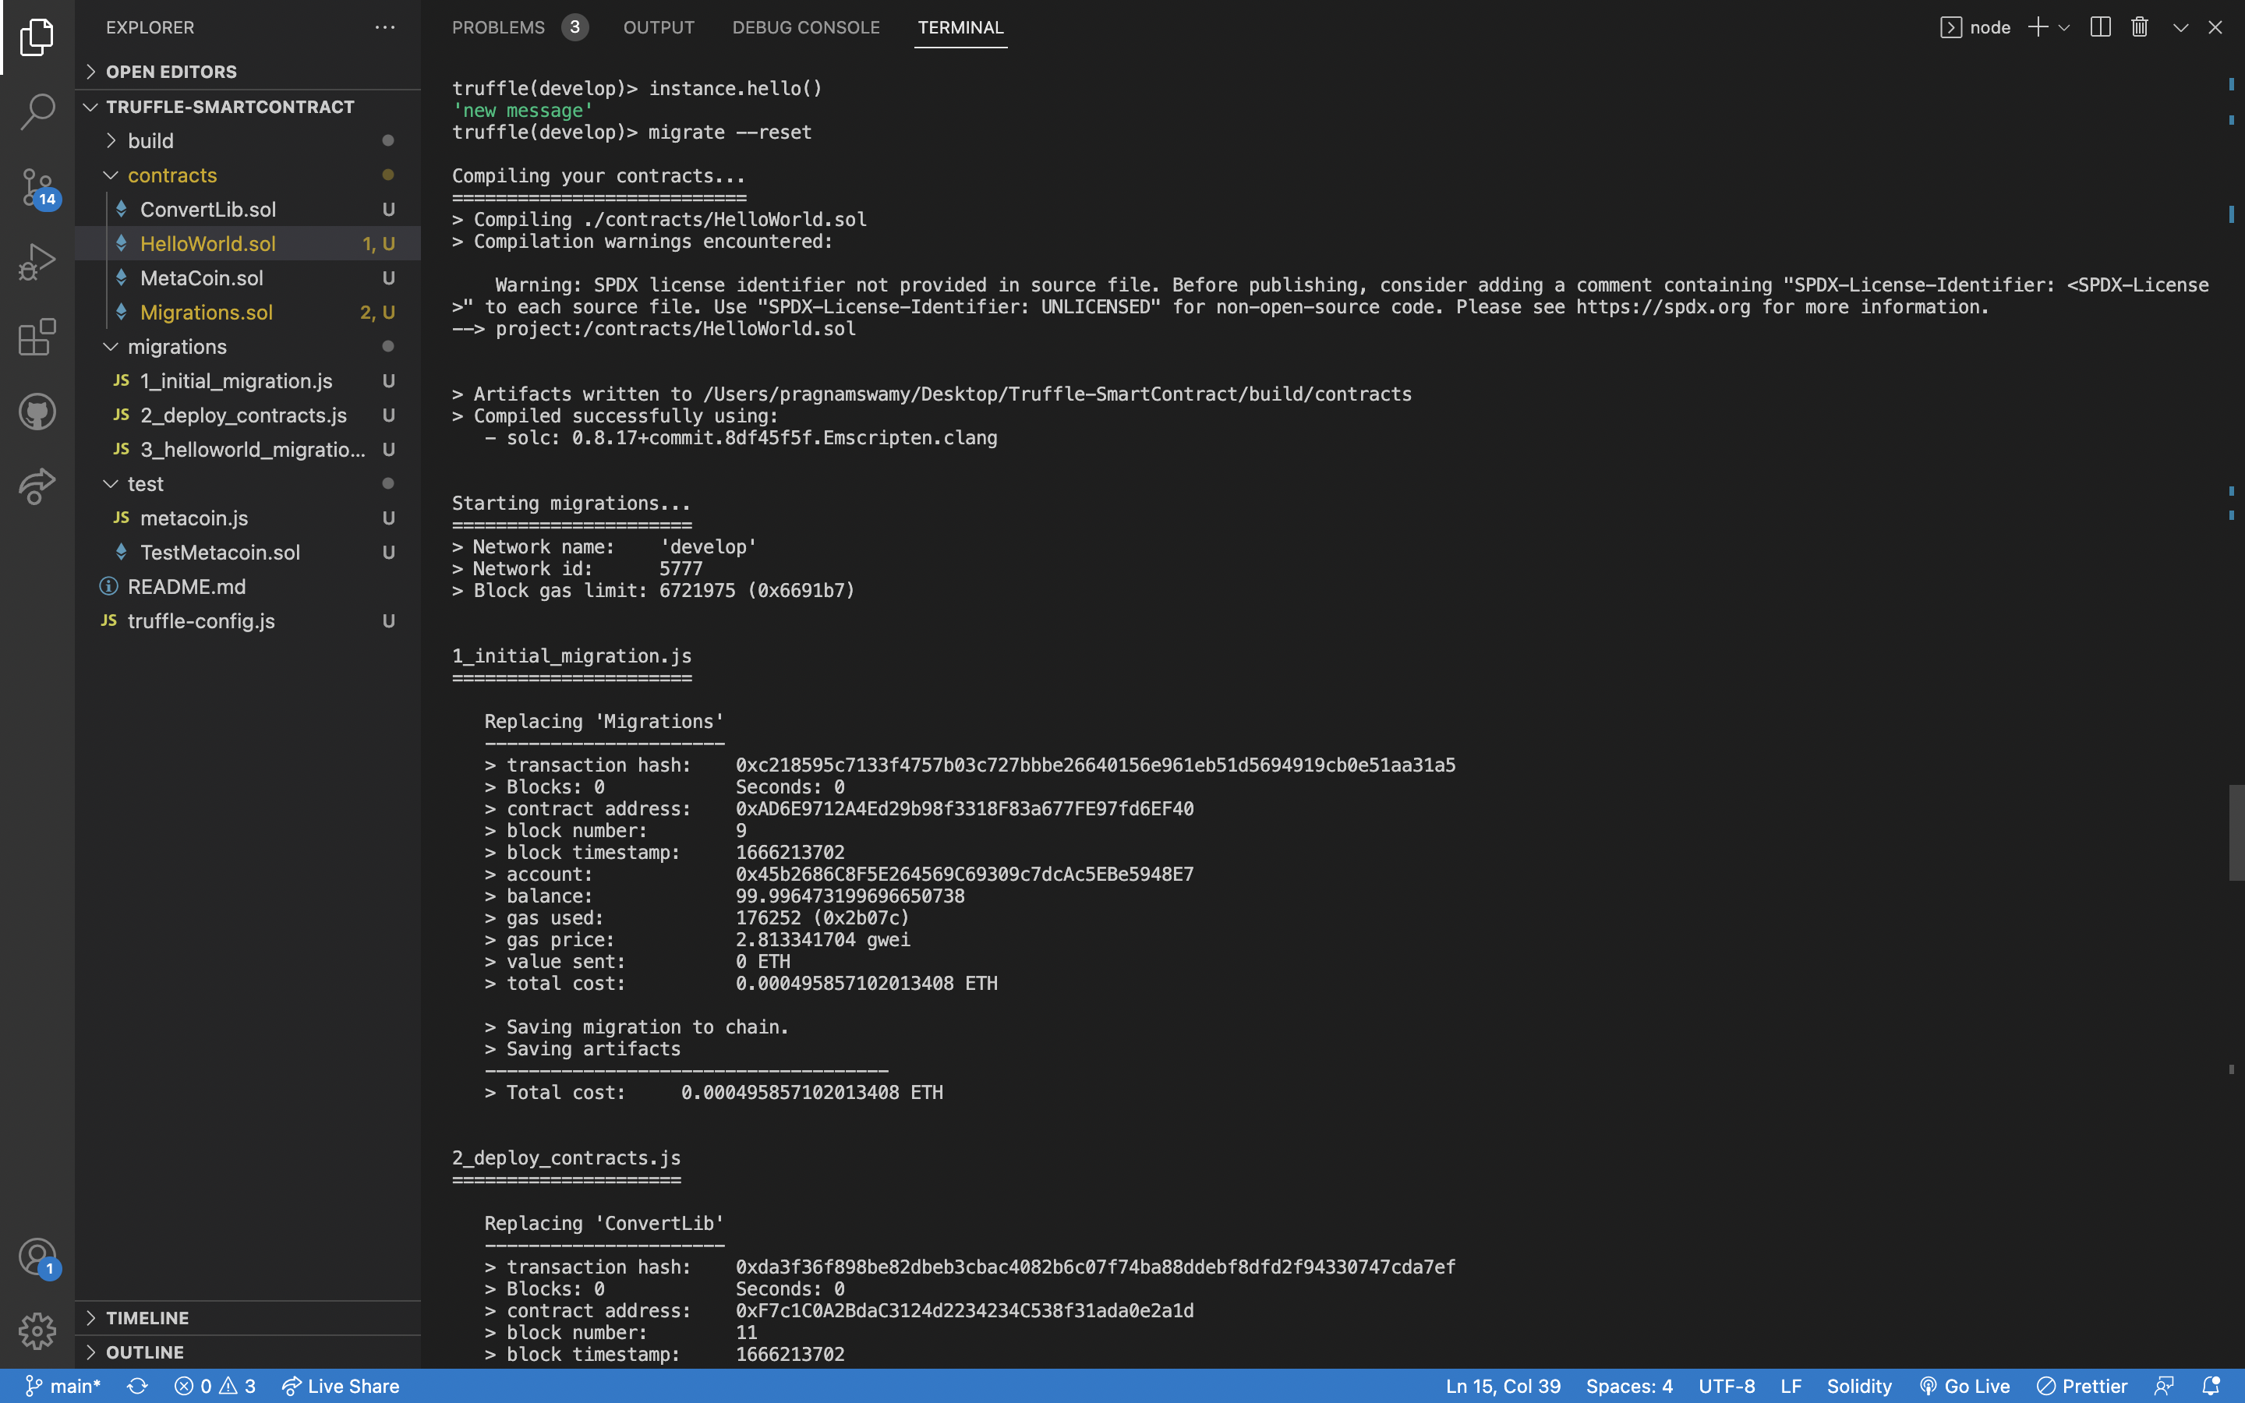

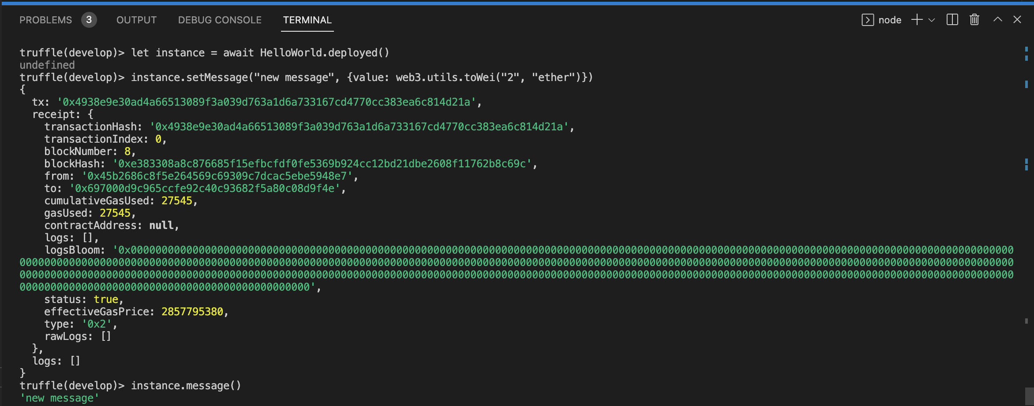

1. Creating another contract HelloWorld2.sol and editing 3_helloworld_migration.js for interaction, compile, migrate –reset and display message.

Notice that total deployments = 5 instead of 4.

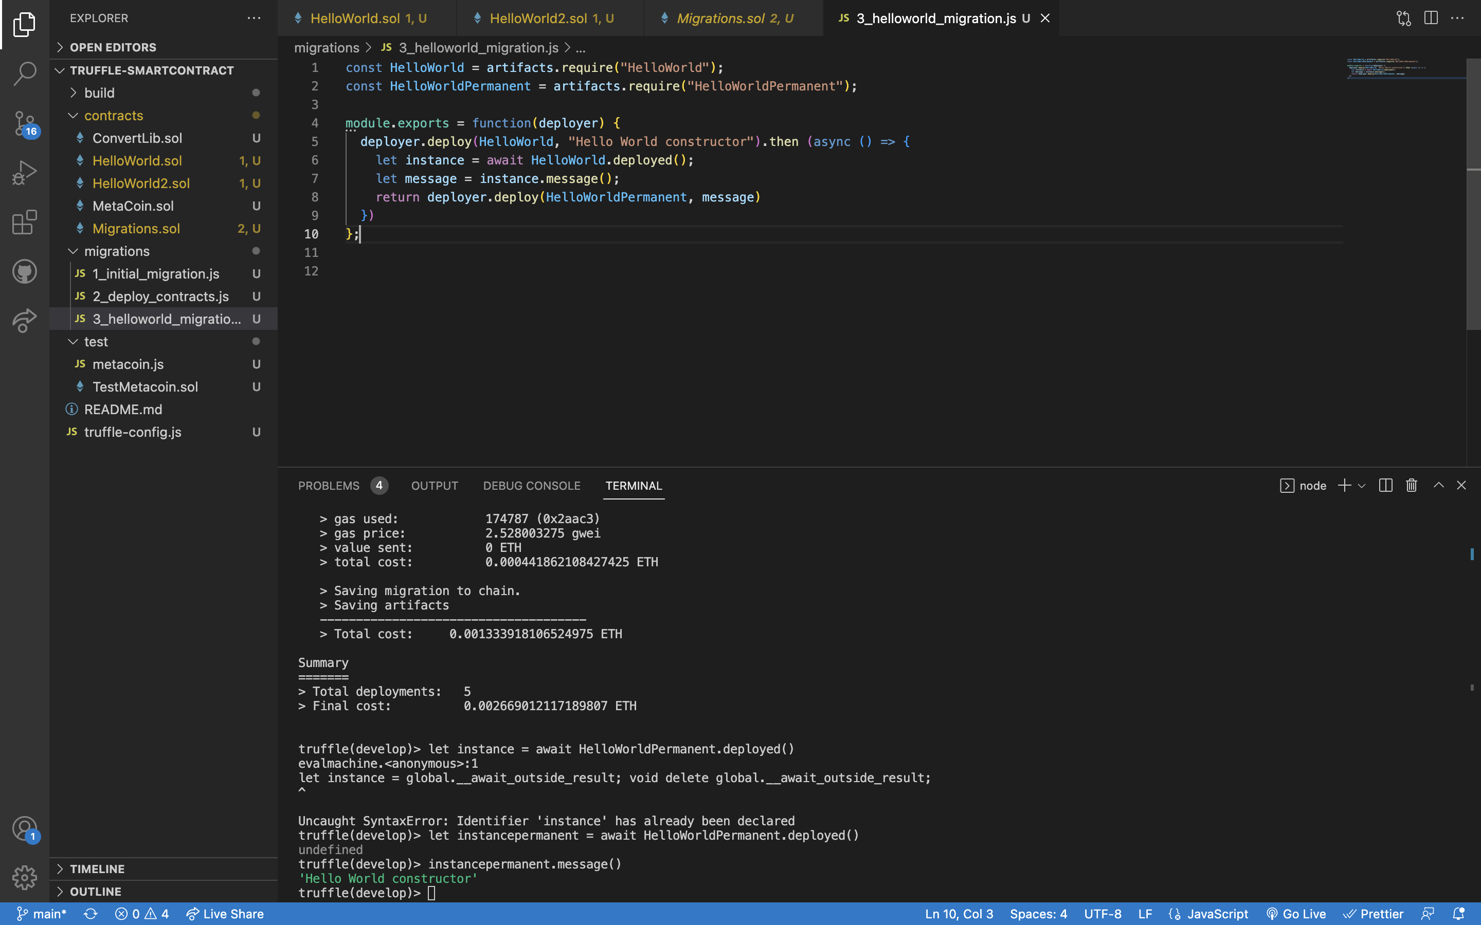

**Video 3: Testing**

1. Create a HelloWorld_test.js file under test folder and run the tests as shown below – Testcase Pass

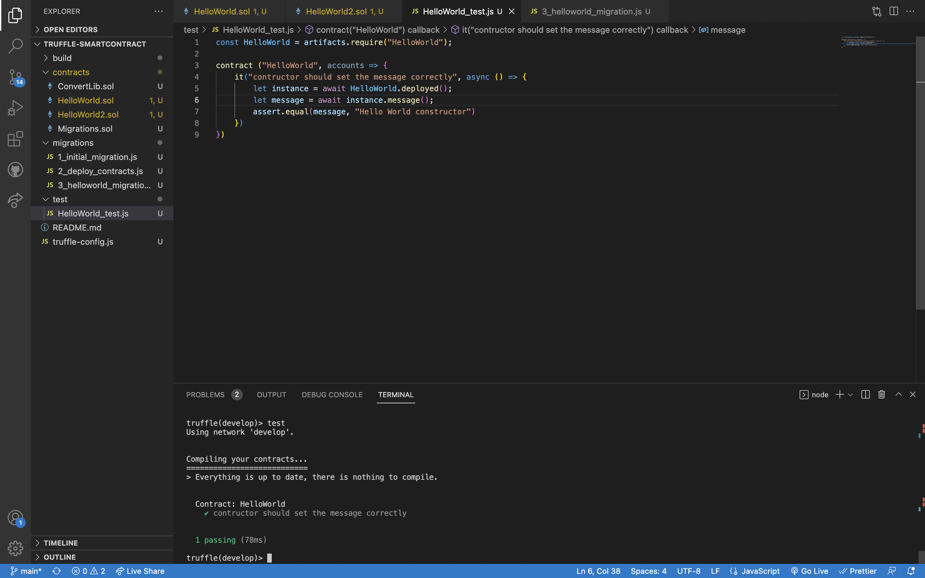

1. Testcase Fail

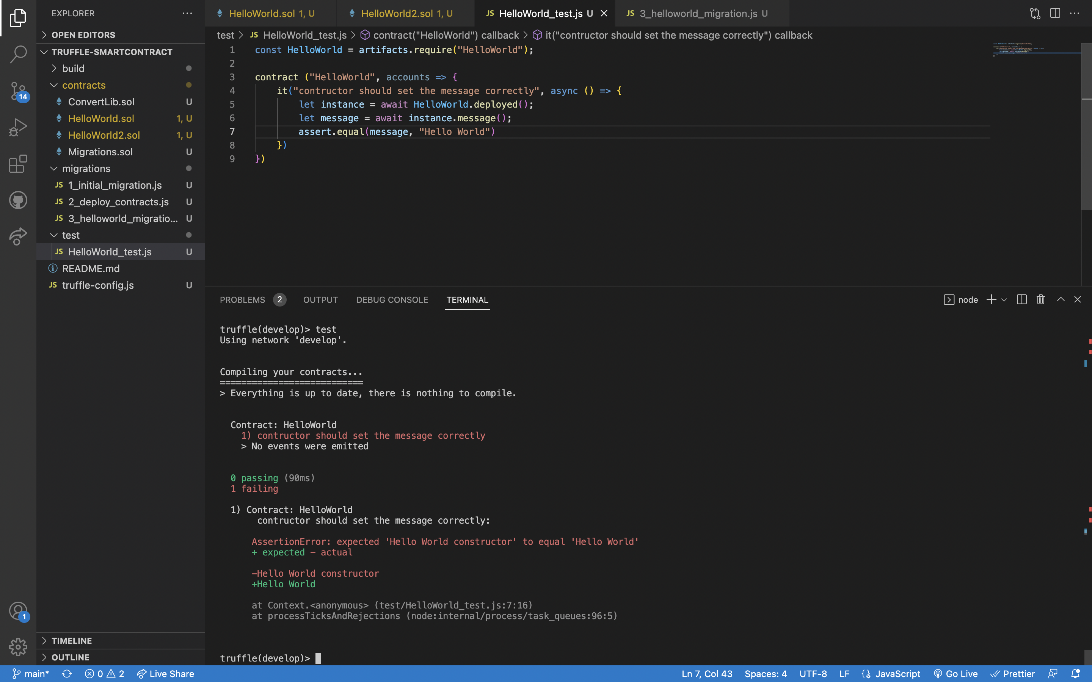

1. Creating another testcase- Account owner should be accounts[0]

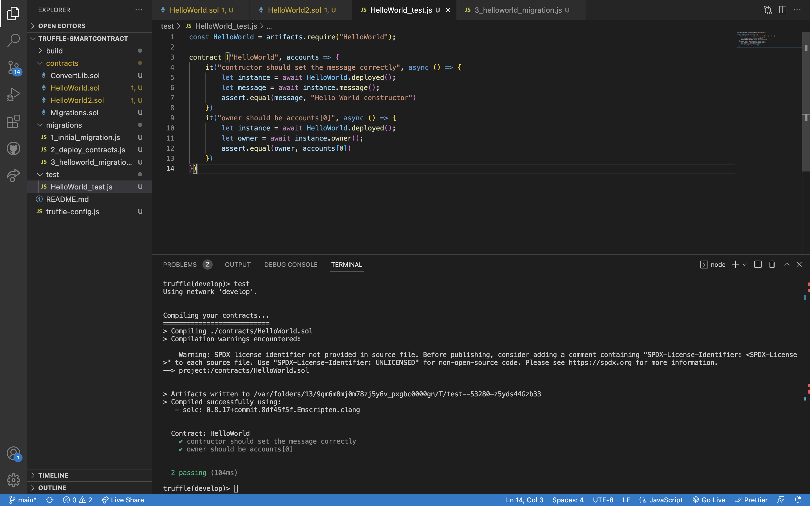

**Video 4: Deployment**

1. Adding AssetTokenized.sol and configurations to truffle-config.js

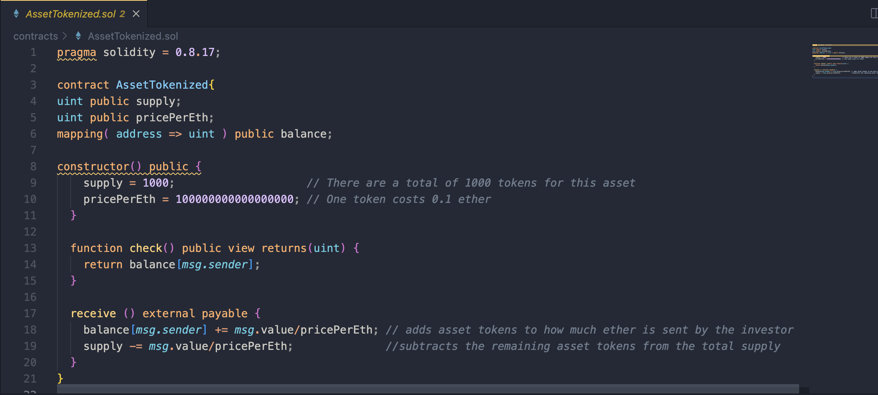

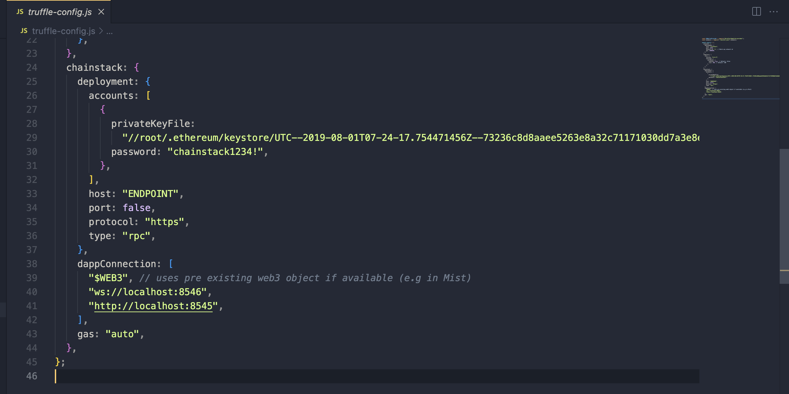

**GitHub Repo Link:**

<https://github.com/PragnaM/Truffle-SmartContract>